**W3-S3** PRACTICE

*CSS SELECTORS & BOX MODEL*

## *At the end of this practice, you should be able to…*

Manipulate CSS basics

• Font and color properties

• Margin, padding, border

• Units (px, %, vh, vw, em)

• Pseudo class (hover, active)

## *How to work?*

* Download **the start code** from the LMS
* Open the folder in VS Code

## *How to submit?*

* **Push** your final codeon **your GitHub repository**
* Then **attach the GitHub path** to the MS Team assignment and **turn it in**

## *Are you lost?*

*You can read the following documentation to be ready for this practice:*

* [Guide - WC3 School](https://www.w3schools.com/css/css3_flexbox.asp)
* [Guide - Flexbox properties](https://css-tricks.com/snippets/css/a-guide-to-flexbox/)
* [Video – Flex in 10 minutes!](https://www.youtube.com/watch?v=GteJWhCikCk&ab_channel=BroCode)
* [FLEX EXPLORER](https://bennettfeely.com/flexplorer/)

# EXERCISE 1

Using the CSS attributes, you have learned, build the layout pictured below.

* You need to be as close as possible to the **given specification**
* All buttons have the **same rendering**, expect the colors (green, orange, purple)
* You need to **avoid code redundancy** as much as possible

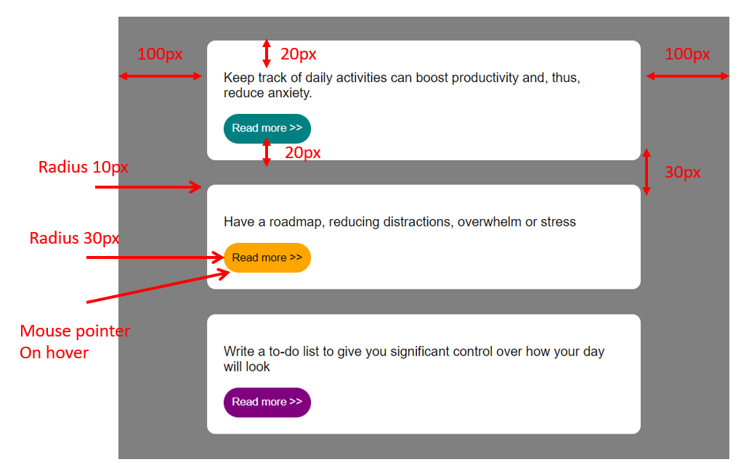

## *How to start?*



* HTML/CSS start code is provided

## *Are you lost?*

**TIP 1** - Here are the CSS properties involved in this exercise:

* padding, margin, border
* cursor
* color, background, border, border-radius

**TIP 1** – Think about the CSS selectors you want to use, in order to avoid code redundancy

* + - Element type selectors
    - Class selectors?
    - ID selectors?

# EXERCISE 2

You have 8 challenges, and 6 bonus challenges to perform.

* Each challenge consists of writing some CSS code to match with the requirements
* You cannot change the HTML code; you need to do everything in the CSS file

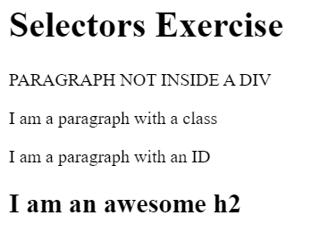

**MANDATORY CHALLENGES**

|  |
| --- |
| Give the <body> element a background of #bdc3c7 |
| Make the <h1> element #9b59b6 |
| Make all <h2> elements orange |
| Make all <li> elements blue (pick your own hexadecimal blue) |
| Change the background on every paragraph to be yellow |
| Make all inputs have a 3px red border |
| Give everything with the class 'hello' a white background |
| Give the element with id 'special' a 2px solid blue border (pick your own rgb blue) |

**BONUS CHALLENGES**

Note: You may need to research some other selectors and properties

|  |
| --- |
| Make all the <p>'s that are nested inside of divs 25px font(font-size: 25px) |
| Make only inputs with type 'text' have a gray background |
| Make all "checked" checkboxes have a left margin of 50px(margin-left: 50px) |
| Make the <label> elements all UPPERCASE without changing the HTML(definitely look this one up |
| Make the first letter of the element with id 'special' green and 100px font size(font-size: 100) |
| Make the <h1> element's color change to blue when hovered over |

# EXERCISE 3

Write the HTML and the CSS code to comply with the bellow design.

* The button shall change its background and border colors when the mouse is hover

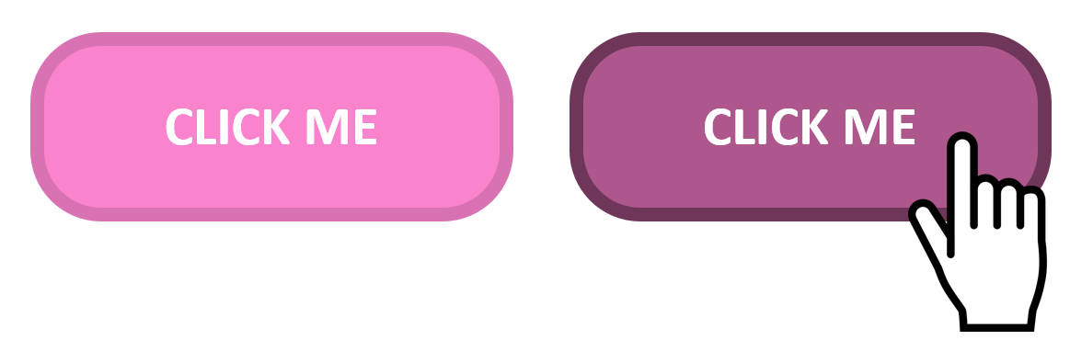

## *Are you lost?*

**TIP 1** – You will need to use the **pseudo selector** to change the button color when mouse is hover.

<https://www.w3schools.com/css/css_pseudo_classes.asp>

# EXERCISE 4

Design and implement a profile card. This card should include

* a profile picture,
* a name, a short bio
* a button for interaction

Be creative, you can design this profile card your own way !!

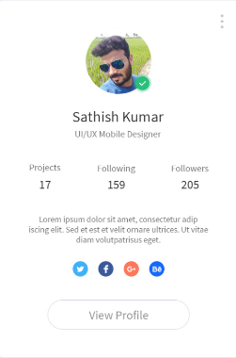

*Just an example*

**HTML**

* A div container for the card.
* An image element for the profile picture.
* A heading for the name.
* A paragraph for a short bio.
* A button for interaction (e.g., "Learn More" or "Contact").

**CSS**

* Use external CSS for the main styling.
* Apply inline or internal CSS for at least one element to demonstrate understanding.
* Use various font and color properties to enhance the card’s appearance.
* Implement Box Model concepts (margin, padding, border) to create a well-spaced layout.
* Create a hover effect for the button.
* Apply a box shadow to give the card a lifted look.